

LAB REPORT

**CSE4020 – MACHINE LEARNING**



**(B.Tech. COMPUTER SCIENCE AND ENGINEERING)**

**FALL SEMESTER 2021-22**

|  |  |
| --- | --- |
| **Name:** | PRASOON SONI |
| **Reg. No:** | 20BCE2960 |
| **Slot:** | L45 + L46 |
| **Faculty Name:** | **JAISANKAR N SIR** |

**VIT – A Place to Learn; A Chance to Grow**

1. **Implement and demonstrate the FIND-S algorithm for finding the most specific hypothesis based on a given set of training data samples. Read the training data from a .CSV file.**

***FIND-S Algorithm***

1. Initialize h to the most specific hypothesis in H

2. For each positive training instance x

For each attribute constraint ai in h

If the constraint ai is satisfied by x

Then do nothing

Else replace ai in h by the next more general constraint that is satisfied by x

1. Output hypothesis h

***Training Example:***

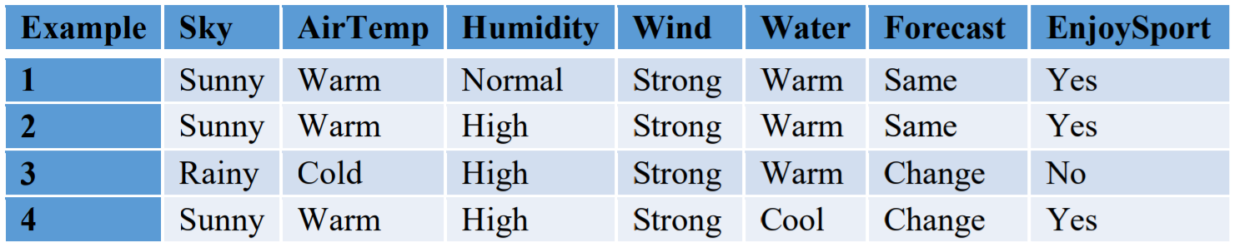

**PROGRAM –**

import numpy as np

import pandas as pd

df = pd.read_csv('data.csv')

print("The Given Training Data Set \n")

print(df.to_string(),"\n")

data = np.array(df)[:,:-1]

print("The attributes are-\n",data,"\n")

target_concepts = np.array(df)[:,-1]

print("The target concepts are :",target_concepts,"\n")

hypothesis = ['0' for i in range(len(data[0]))]

print("The initial value of hypothesis :", hypothesis,"\n")

for i in range(len(target_concepts)):

if target_concepts[i] == 'Yes':

hypothesis = data[i].copy()

break

for i in range(len(data)):

if target_concepts[i] == "Yes":

for j in range(len(data[i])):

if data[i][j] != hypothesis[j]:

hypothesis[j] = '?'

else:

continue

print("For Training Set Example No:",i,"the hypothesis is: ",hypothesis,"\n")

print()

final_hypothesis = hypothesis.copy()

print("The maximally Specific Hypothesis for a given Training Examples:",final_hypothesis,"\n")

**OUTPUT –**

The Given Training Data Set

Sky Temp Humid Wind Water Forecast EnjoySpt

0 Sunny Warm Normal Strong Warm Same Yes

1 Sunny Warm High Strong Warm Same Yes

2 Rainy Cold High Strong Warm Change No

3 Sunny Warm High Strong Cool Change Yes

The attributes are-

[['Sunny' 'Warm' 'Normal' 'Strong' 'Warm' 'Same']

['Sunny' 'Warm' 'High' 'Strong' 'Warm' 'Same']

['Rainy' 'Cold' 'High' 'Strong' 'Warm' 'Change']

['Sunny' 'Warm' 'High' 'Strong' 'Cool' 'Change']]

The target concepts are : ['Yes' 'Yes' 'No' 'Yes']

The initial value of hypothesis : ['0', '0', '0', '0', '0', '0']

For Training Set Example No: 0 the hypothesis is: ['Sunny' 'Warm' 'Normal' 'Strong' 'Warm' 'Same']

For Training Set Example No: 1 the hypothesis is: ['Sunny' 'Warm' '?' 'Strong' 'Warm' 'Same']

For Training Set Example No: 2 the hypothesis is: ['Sunny' 'Warm' '?' 'Strong' 'Warm' 'Same']

For Training Set Example No: 3 the hypothesis is: ['Sunny' 'Warm' '?' 'Strong' '?' '?']

The maximally Specific Hypothesis for a given Training Examples: ['Sunny' 'Warm' '?' 'Strong' '?' '?']